Shortest Path Assignment

# Introduction

This assignment consists in creating a graph as a ADT in C++ to test the distances to all vertex using Dijktra’s algorithm of shortest path. It is implemented using matrices and creating random graphs with densities of 20% and 40% on a graph of 50 nodes with distance range of 1 to 10.

# Output of the program

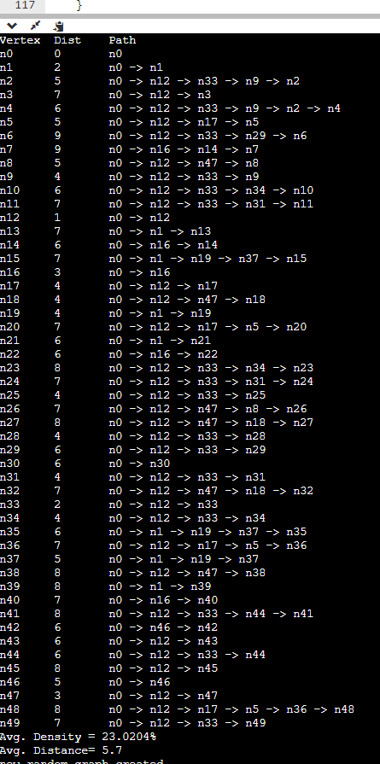

# What I learned

This assignment helped me understand templates, classes, objects and a lot more. I understood how a graph shows a connection between vertex and how to decide on a short route using Dijkstra’s algorithm. I also used vectors for the first time, as a more powerful array with verifications on size and function to add or remove members of the vector while also experimenting on c++ arrays. I found how useful are templates for creating function overloads with only one generic type but I stumbled on using arrays while conflicting con char* differences with number. The public and private members of the class where useful to give the user the most user friendly functions. I also learned how to write multiple classes in multiple files, and I created several files. The best part was seeing it all work together.

# Code is attached :D!